The Rapture of the Church
Guided Growth with Pastor Keith @ CBC Wed. Sept 23rd
Prophecy is like a puzzle portraying the Story and Struggle of the ages IN ADVANCE!
“Prophets” were handed “pieces” of History’s puzzle in advance! At least 353 of these pieces dealt specifically with Jesus’ 1st coming. http://www.accordingtothescriptures.org/prophecy/353prophecies.html
Jesus fulfilled every one of them! (Luke 24:46) Studying God’s word is necessary to learn how to rightly put the pieces of the “Prophetic Puzzle” together! (2 Tim. 2:15) Most missed Jesus’ first coming because they were focused on the prophecies that were about his 2nd Coming! (Jn. 5:39-4)
In addition to the O.T. prophecies of Jesus’ second coming there are more than 100 N.T. prophecies about his second coming! If Jesus fulfilled all of the prophecies about his 1st coming, He will certainly fulfil the O.T. and N.T. ones about his second coming! (Mt. 5:18) Scripture reveals that there will be two distinct “stages: to his Second Coming.
- 1st: He will come “in the air” for His Church! (Acts 1:11; 1 Thes. 4:13-18; 1 Cor. 15:51-58)
- 2nd Stage He’ll come “in power” to reign on the earth. (Ps. 2; Zech.12; 2 Thes. 2; Rev. 19)

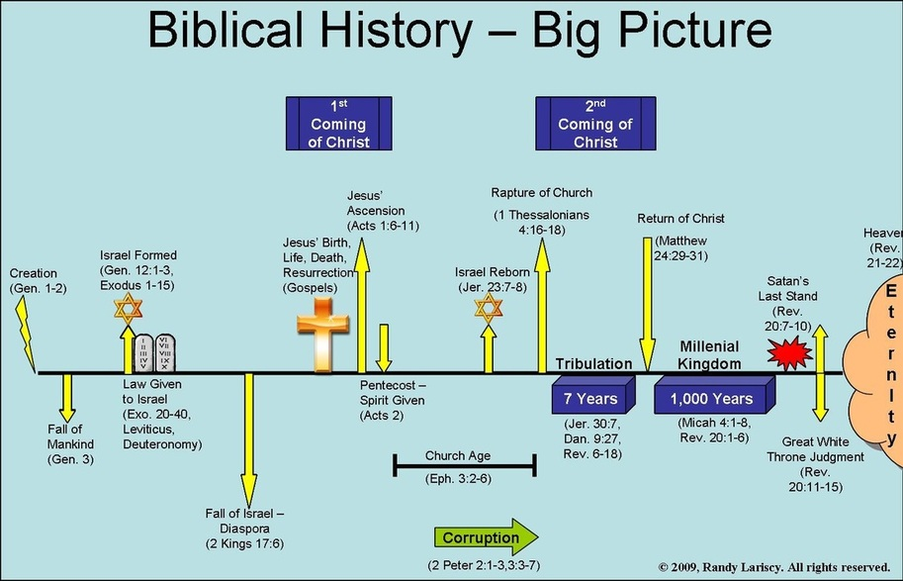

The next prophetic “piece of the puzzle” is the Rapture of the Church. “Revelation” is divided into three distinct phases. Re 1:19 “Write the things which thou hast seen, (Ch. 1) and the things which are, (Church age: Ch. 2-3) and the things which shall be hereafter” (4-22) The “Age of Grace” will end with the “Rapture” of His Church. Jn 14:3
The “What” Of The Rapture:
The literal transporting of the saints to Heaven. (Jn 14:2; 1 Th. 4:13-18; 1 Cor. 15:50-58; Rev 4)
1) “caught up together” (1 Thes. 4:17) is harpadzo meaning “to remove, or take away.”
2) The English word Rapture comes from the Latin "raptus":to seize or transport.”

The “WHY” of the Rapture. The Rapture will initiate our:
1. Transformation. 1Co 15:51-54 “I shew you a mystery; We shall not all sleep, but we shall all
be changed, (Allasso: made different. ) in the twinkling of an eye, at the last trump: for the trumpet
shall sound, and the dead shall be raised incorruptible, (undecaying)

2. Evaluation: 2 Cor. 5:10 “we must all stand before the judgment seat (Bema) of Christ…”
(see also 1 Cor. 3:10-15; 2 Tim. 4:1,2; Heb.13:17; Mt. 25:13-30; Rev 4)
- The Bema Seat. Rev 4:1-3 “After this I looked, and, behold, a door was opened in heaven: and the first voice which I heard was as it were of a trumpet talking with me; which said, Come up hither, and I will shew thee things which must be hereafter. and immediately I was in the spirit: and, behold, a throne was set in heaven, and one sat on the throne. And he that sat was to look upon like a jasper and a sardine stone: and there was a rainbow round about the throne, in sight like unto an emerald.”
- Stones based on the High Priest’s breastplate. (Ex. 28:17-20)
- Sardine (Blood Red) representing Reuben: “Behold a Son”
- Jasper (White) representing Benjamin: “Son of my right hand” (POWER)
- Emerald: (Green) representing Judah: “Praise”
2) The Elders Rev 4:4-5 “round about the throne … I saw 24 elders sitting”
- In 1 Chron. 24 the priesthood was divided into 24 “courses”.
b) Since we’re a “Royal Priesthood” (1 Pt 2:9) These represent the whole “church”.
3) The Lamps of Fire (Rev. 4:5; Is. 11:1,2) represent The Holy Spirit evaluating our works.
(1 Cor. 3:13,14)

C. Remuneration. (Rewards) Rev 4:4-5,10-11 “they had … crowns of gold.”
1) Crowns of Gold for faithful service! (Mt. 25:14-21; Rev. 1:5; 2 Tim. 4:8)
Rev 22:12 “behold, I come quickly; (tachu: suddenly) and my reward (misthos: Pay for service!)
is with me, to give every man according as his work shall be.” (also Eph. 4:1)
2) Crowns were returned in gratitude and worship. (Rev. 4:10,11) (See Col. 1:12-18)

Conclusion: The Rapture will be about our:
- Transformation 1 Cor 15:51; 1 Th. 4:16,17; 1 Jn. 3:1-3
- Evaluation. (1 Cor. 3:10-18; 2 Cor 5:10)
- Remuneration. (Mt. 25:14-30; 2 Tim. 4:8; Rev. 21:12)
Application: Luke 19:11-27 Jesus “spake a parable, … because they thought that the kingdom of God should immediately appear. .. A certain nobleman went into a far country to receive for himself a kingdom, and to return. And he called his servants, and delivered them ten pounds, and said unto them, Occupy till I come.” (to busy yourself with trade)
What are you “occupied” with? (See Mark 4:19; Mt. 6:33,34)
15 “And it came to pass, that when he was returned, having received the kingdom, then he commanded these servants to be called unto him, to whom he had given the money, that he might know how much every man had gained by trading.”
- Those who were “occupied” with the Lord’s business Were richly rewarded. Vs 16-19
- Those that were not suffered loss! (Vs. 20-26) See also 1 Cor 3:10-15
- Those who refused his authority were killed (Vs 27)
Which group best represents you?

